RoHS Certificate of Compliance

We hereby declare that the products listed meet the requirements within the Restriction of Hazardous Substances (RoHS) Directive-
2011/65/EU; 2006/66/EC; IEC 62321: 2013
The materials used in these products contain less than the directed amounts of RoHS-banned substances by weight:

Series ST-329, ST-329BL LED Stroboscopes

Signature: 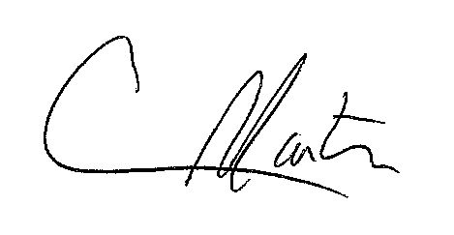

Craig Martin
Global Sales & Marketing Manager


