EU Declaration of Conformity

We hereby declare that the product described below:

MT-100 CONTACT TACHOMETER

Complies with the provisions of the following European Directives:

EMC Directive 2004/108/EC

Complies with the provisions of the following harmonized standards:

EN61000-4-2 / A1: 1998-10
EN61000-4-2: 1995 / A1: 1995

Date of Issue: August 10, 2021

Signature: 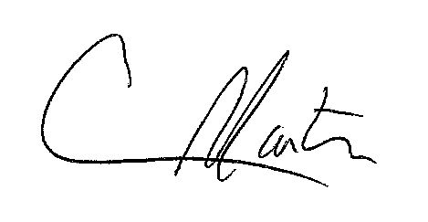

Craig Martin
National Sales & Marketing Manager
